Please PRINT in BLOCK LETTERS and FAX, E-MAIL or AIRMAIL with payment receipt to:
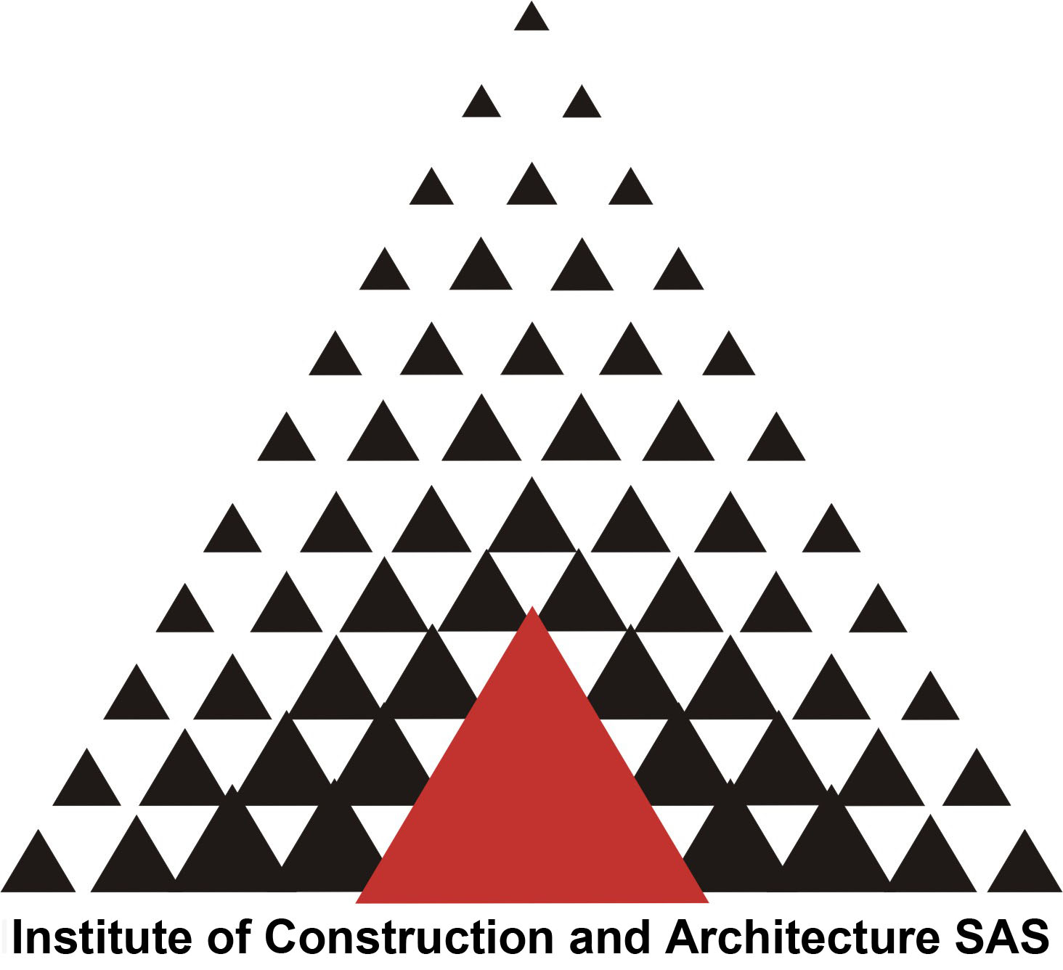
Miroslav Kocifaj

ÚSTARCH, Slovak Academy of Sciences
Dúbravská cesta 9,
845 03 Bratislava
Slovak Republic, EUROPE

Fax ++421 2 5477 3548
E-mail: kocifaj@savba.sk

Identification
Please complete this section accurately. The information you provide will allow us to correspond with you efficiently.

Participant
Title :  Prof.    Dr.    Mr.    Mrs.    Ms.
Gender: Male Female
Family Name
First Name
E-mail

Accommodation
(book your hotel stay early/no later than October 1st, 2013. After the deadline, room availability will be on request)

The majority of accepted participants will be housed in Smolenice Castle. Castle was rebuilt in the romantic style and now offers full accommodation and conference comfort. If needed, some participants can be accommodated in the three-star Hotel Solmus in Smolenice village. There are only a very limited number of single rooms in the Castle, so almost all participants will have to be assigned to two-bed or other rooms. If you want to be alone in a multiple bed room, you will be charged for the complete room rate. We kindly ask the participants to indicate the name(s) with whom they wish to share the room (see the next page of this FORM). It may happen that some corrections to your reservation have to be made, so any further details will be communicated after receiving all the registrations. All rates in Smolenice Castle are per person and include VAT:
- 90 € / complete apartment / two beds / one night
- 45 € / shared apartment / one bed / one night
- 80 € / four-bed room / four beds / one night
- 20 € / shared four-bed room / one bed / one night
- 72 € / three-bed room / three beds / one night
- 24 € / shared three-bed room / one bed / one night
- 60 € / two-bed room / two beds / one night
- 30 € / shared two-bed room / one bed / one night
- 30 € / one-bed room / one bed / one night

Alternative accommodation in the vicinity of Smolenice Castle is available at the hotel Solmus (http://www.uby.sk/garni-hotel-solmus-smolenice?locale=en), which is located about 3 km from the Castle. The hotel usually provides shuttle bus transportation for free. The rate in Hotel Solmus is:
- 35 € single room/night
Note: The daily meals are provided for all registered participants (see the REGISTRATION FORM).
Please indicate in the box below if you require vegetarian meals:

Strictly vegetarian menu:

RESERVATION:
The payment for reserved accommodation can be made in cash at arrival in Smolenice, but only in €.
The receipt will be issued by the hotel for the total amount of your stay.

Attention: If you prefer to pay in advance, please contact the organizers. Because of the limited number of single or double rooms, this payment is only possible after your room-reservation is confirmed by the organizers.

The actual conference starts with lunch on Tuesday (November 5th) and will be closed after lunch on Thursday (November 7th) in Smolenice. The pre-conference dinner will be held in the hotel Matyšák in Bratislava (http://www.hotelmatysak.sk/en/) on Monday (November 4th). We kindly ask participants to take care of their Hotel reservation themselves indicating OCAA2013 in their e-mail correspondence. The cost for one person in a double room is about 81 €, while the cost for one person in a shared double room is 56 €. Rooms are limited in hotel Matyšák, so we do suggest booking as soon as possible. We expect most attendees will stay in the hotel Matyšák on Monday night, but some may wish to book other hotels in Bratislava. Hotel Matyšák is centrally located and easy to reach.

Detail information will be provided after October 1st and distributed to all participants by e-mail and/or through the conference website.

In Smolenice (Tuesday and Wednesday), please reserve:

Hotel : Smolenice Castle Hotel Solmus

Type of room required (please specify):
Arrival Departure Number of nights
* I can share my accommodation with:

Transportation Bratislava – Smolenice - Bratislava
Transportation buses from Bratislava to Smolenice on November 5th in the morning and from Smolenice to Bratislava on November 7th after lunch are provided by conveners and included in your registration fees.

Please check the appropriate box if you want to benefit of the buses.

I will take bus transportation Bratislava – Smolenice on November 5th about 9:00 AM at hotel Matyšák.

I will take bus transportation Bratislava – Smolenice on November 5th about 10:00 AM at the airport.

I will take bus transportation Smolenice – Bratislava on November 7th after lunch

The bus will stop in hotel Matyšák around 9:00 AM and then around 10:00 AM at the airport. Afterwards the bus will transport all the passengers directly to Smolenice. The accommodation in hotel Matyšák has to be paid at the hotel desk. You can make the reservation by e-mail to hotel@hotelmatysak.sk. If you need help, do not hesitate to contact Miroslav Kocifaj (Miroslav.Kocifaj@savba.sk).

Date Signature
I hereby authorize the processing of my personal data in compliance with D. Lgs. 30/06/2003 N° 196 on personal data handling only for this Congress management.

